DATED:31-05-2024

Analyse the historical data of bike sharing company Cyclistics

# OBJECTIVE:

To understand the differences in usage patterns between annual members and casual riders of Cyclistic's bike-share program.

# CONTEXT:

Cyclistic is a bike sharing company, seeking to increase the number annual membership. Annual members are more profitable than casual riders, and converting casual riders into annual members is seen as a key strategy for future growth. To develop effective marketing strategies, the team needs insights into how these two groups use Cyclistic bikes differently.

# SCOPE:

This analysis will focus on comparing the usage patterns of annual members and casual riders using Cyclistic's historical bike trip data. It will identify key differences in terms of trip duration, frequency, time of use, and popular routes.

# DELIVERABLES:

1. A clear statement of the business task.
2. A description of all data sources used.
3. Documentation of any cleaning or manipulation of data.
4. A summary of the analysis.
5. Supporting visualizations and key findings.
6. Top three recommendations based on the analysis.

# TIMELINE:

The task will be completed within one week

# DATA USED:

• **Source Name:** cyclistic

• **Description:** This source includes data collected directly from the bikes equipped with sensors and GPS devices.

• **Data Collected:** Trip start and end times, trip duration, distance traveled, routes taken, bike locations.

• **Collection Method:** Real-time data collection via integrated sensors and GPS trackers on each bike, transmitted to the central database.

• **Credibility:** High credibility as data is collected automatically and directly from the bikes, ensuring accuracy and minimizing human error.

### Project Presentation: Cyclistic's Strategy to Convert Casual Riders to Annual Members

#### Overview

Cyclistic, a bike-share company in Chicago, is looking to enhance its business strategy by focusing on converting casual riders into annual members. The marketing director believes that maximizing the number of annual memberships is crucial for the company's future success. To support this goal, our team has analyzed usage patterns of both casual riders and annual members. The following insights and visualizations highlight the differences in how these two groups use Cyclistic bikes, providing a data-driven foundation for our marketing strategy recommendations.

#### Data Insights and Visualizations

##### 1. Number of Rides per Day

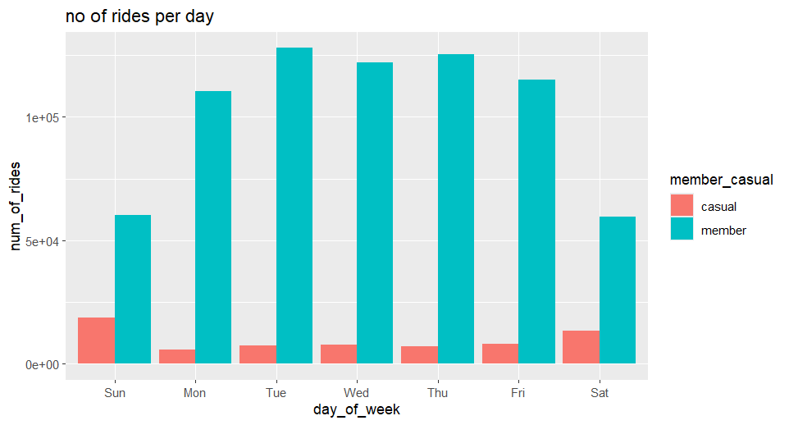

This bar chart shows the number of rides taken by casual riders and annual members across different days of the week. The key observations are:

* **Annual Members**: Ride significantly more on weekdays (Monday to Friday) with the peak on Tuesday and Wednesday.
* **Casual Riders**: Ride more on weekends, with a noticeable increase on Saturday and Sunday.

These patterns suggest that annual members primarily use Cyclistic bikes for commuting during the workweek, while casual riders use them more for leisure activities on weekends.

##### 2. Average Duration per Day

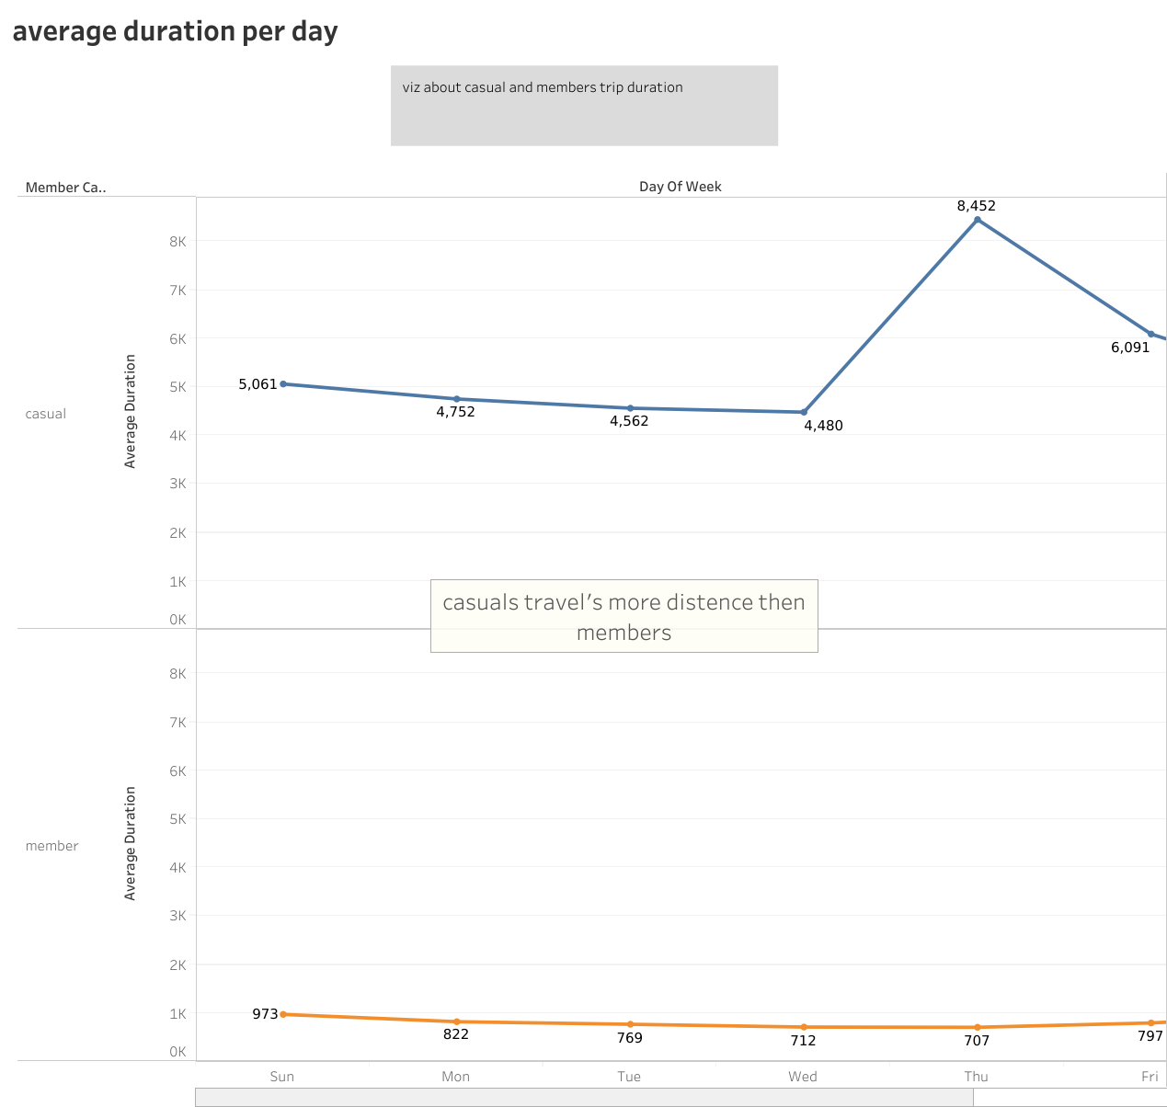

This line graph illustrates the average duration of rides for casual riders and annual members throughout the week. Key insights include:

* **Casual Riders**: Consistently have longer trip durations, peaking significantly on Saturday.
* **Annual Members**: Have much shorter and consistent trip durations throughout the week, indicating utilitarian use rather than recreational.

The longer ride durations by casual riders, especially on weekends, highlight a potential for marketing strategies that emphasize the value of annual memberships for leisure and extended use.

#### Recommendations for Marketing Strategy

Based on the insights from our data analysis, we propose the following strategies to convert casual riders into annual members:

1. **Weekend Specials for Members**:
   * Promote special weekend offers exclusively for annual members, such as discounted rates or additional ride time.
   * Highlight the convenience and cost savings of becoming a member for frequent weekend use.
2. **Commuter Benefits**:
   * Emphasize the advantages of annual memberships for daily commuting, including potential partnerships with local businesses for commuter perks.
   * Offer trials or limited-time discounts on annual memberships to frequent casual riders identified from weekday usage patterns.
3. **Leisure and Lifestyle Campaigns**:
   * Create marketing campaigns that position Cyclistic as a lifestyle choice, ideal for both daily commutes and weekend leisure activities.
   * Use testimonials and stories from current members who enjoy both commuting and recreational rides.
4. **Targeted Promotions**:
   * Utilize data analytics to identify high-usage casual riders and target them with personalized membership offers.
   * Implement referral programs where existing members can invite casual riders to join at a discounted rate.

#### Conclusion

The compelling data insights and visualizations demonstrate clear usage patterns that differentiate casual riders from annual members. By understanding these patterns, we can design targeted marketing strategies to encourage casual riders to become annual members. Our recommendations focus on leveraging the unique needs and behaviors of both commuter and recreational users to maximize the number of annual memberships, driving Cyclistic's future success.

We look forward to your approval to implement these strategies and transform our casual riders into loyal, annual members.